**Project 7 Coin Detection with OpenCV**

Name: _Riya Dev_______________________ Period: _7__________ Date: _3/25/2022__________

Did you name your file l071.cpp (Lower case L, then 071)? _yes___

Did you use OpenCV to detect coins? _yes__________

Did you test your code on terminal/gnu linux in c++11? _yes__________

What functions/methods from OpenCV did you use?

imread(filename, IMREAD_GRAYSCALE);

imwrite("imageg.jpg", grayscale);

blur(grayscale, blurred, Size(5,5));

cv::Canny(blurred, detected_edges, low, high);

HoughCircles(detected_edges, houghcircles, HOUGH_GRADIENT, 1, 50, 50, 30, 76, 130);

circle(img, center, 1, Scalar(0, 0, 0), 3, LINE_AA);

__________________________________________________________________________________

What functions/methods from OpenCV did you experiment with but ended up not using?

imshow("detected circles", img);

imshow("Display window", img);

Run your code (the same code you submit) on the 3 images I provided (easy, medium, hard) then paste here the following:

* The initial image ( the one I provided), the imageg.jpg, imagef.jpg, coins.jpg you obtained running your code, copy paste here the content of your results.txt file your code created

1. For the easy image:

Command line including all parameter values used for this image:

./l071

Initial image:

​​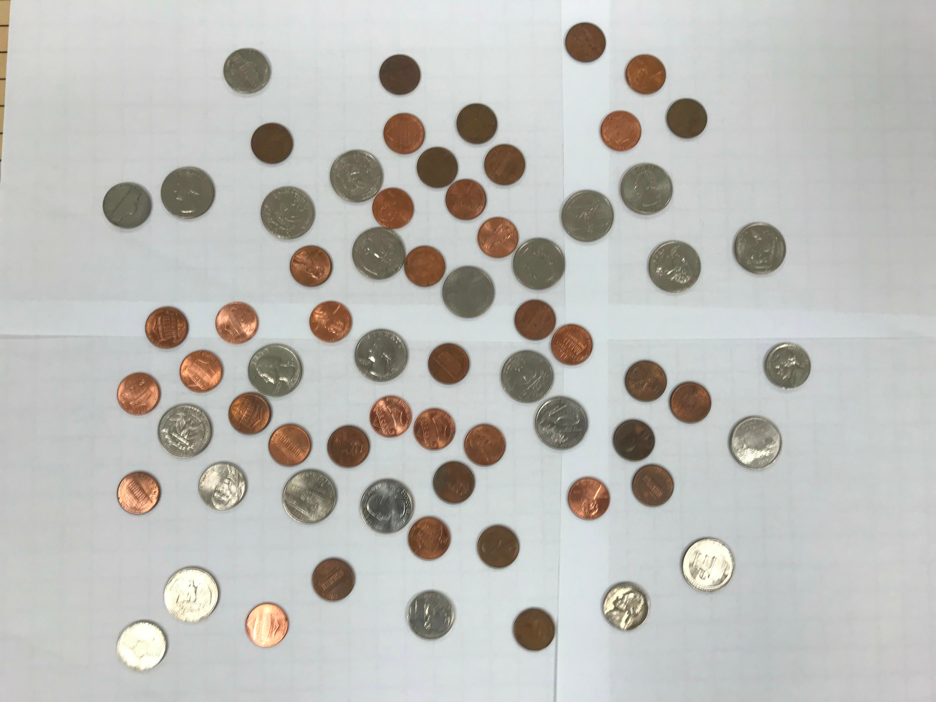

imageg.jpg:

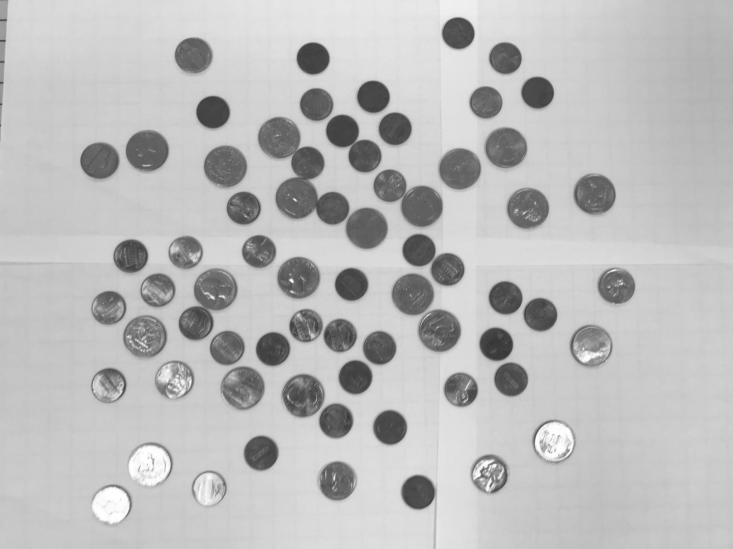

imagef.jpg:

​​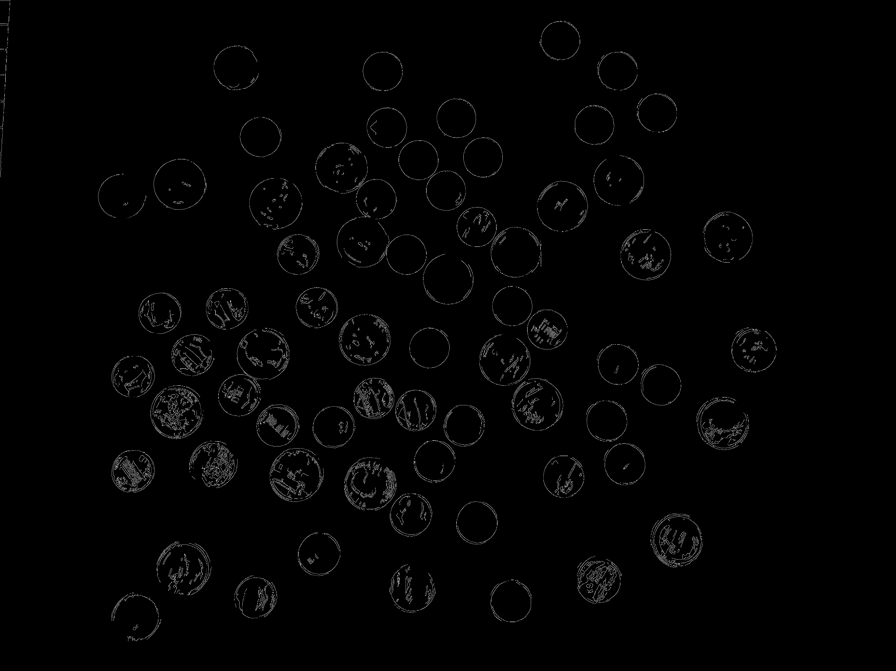

coins.jpg:

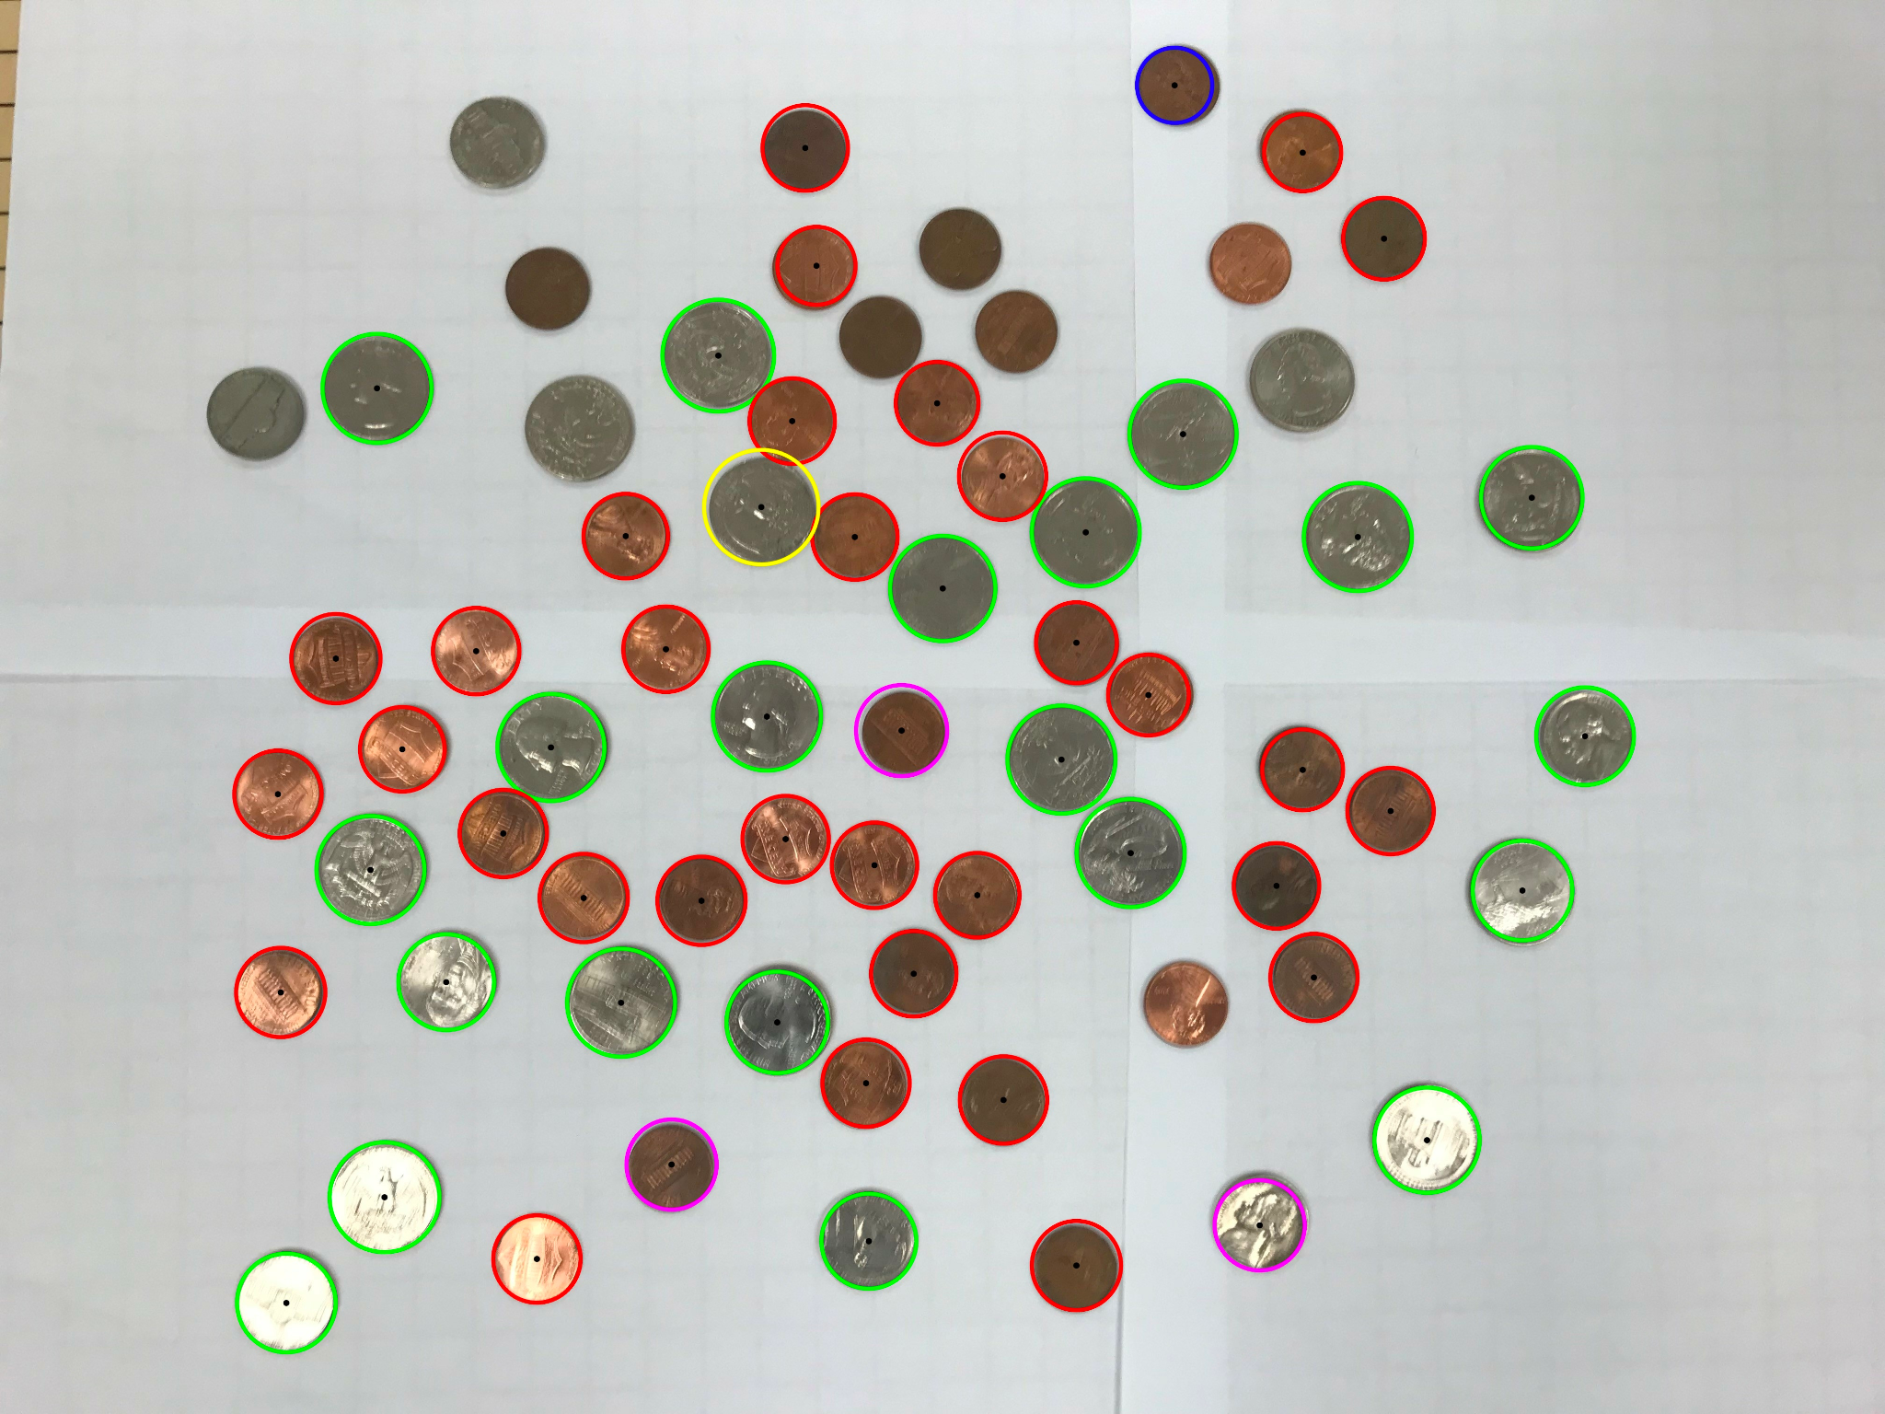

Content of results.txt:

1 dimes, 32 pennies, 3 nickels, 21 quarters, 1 silver dollars. Total sum: $6.32

1. For the medium image:

Command line including all parameter values used for this image:

./l071 -L 10 -H 100 -F coins2.jpg

Initial image:

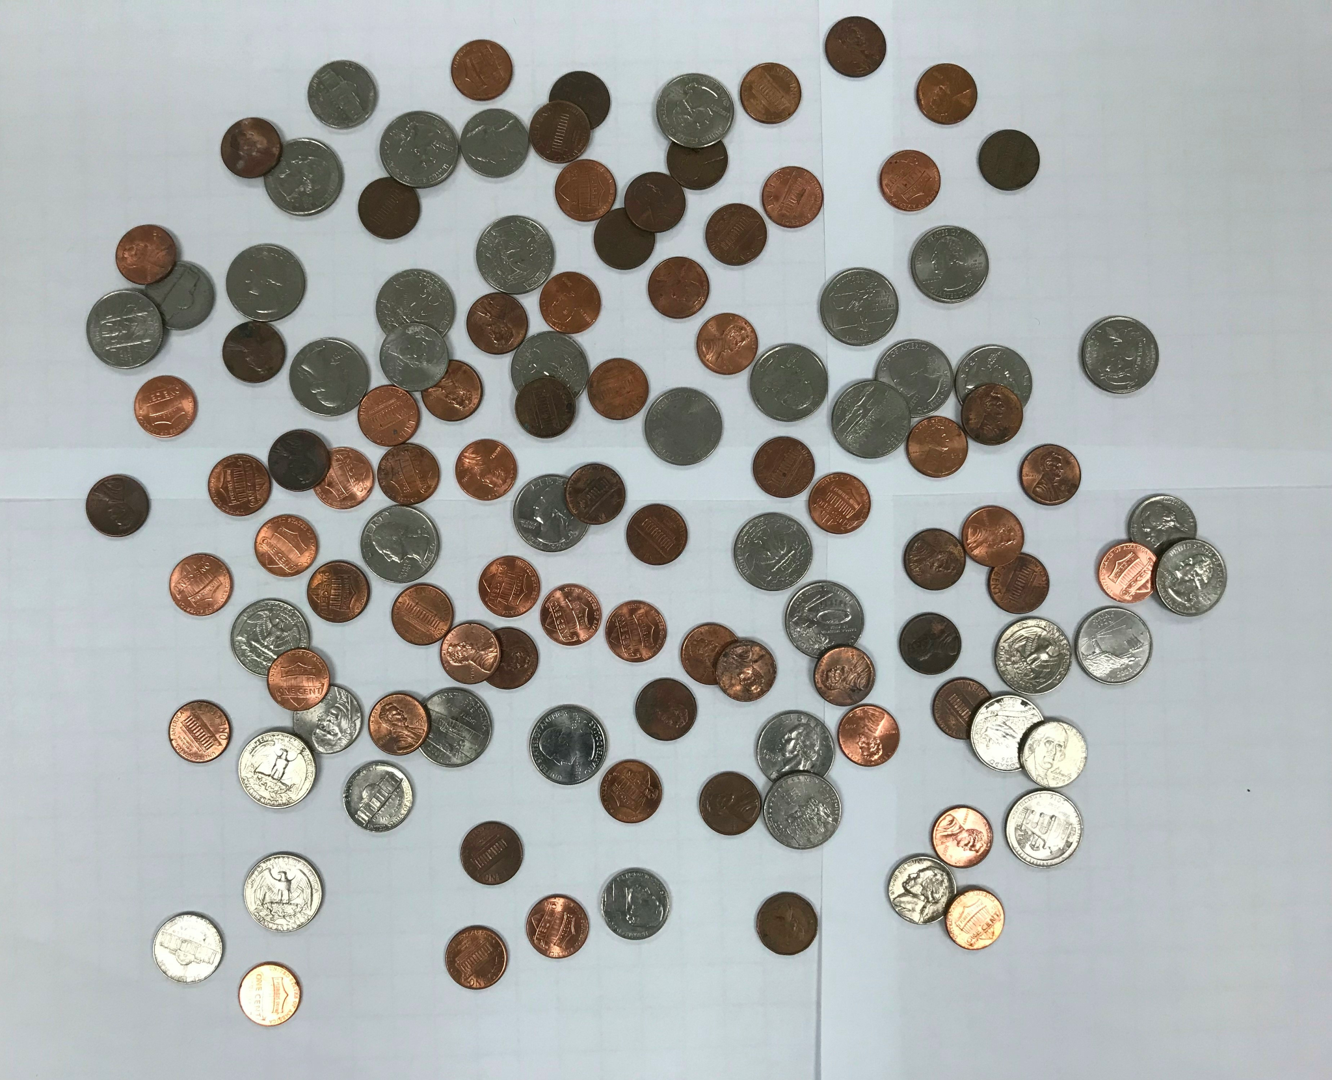

imageg.jpg:

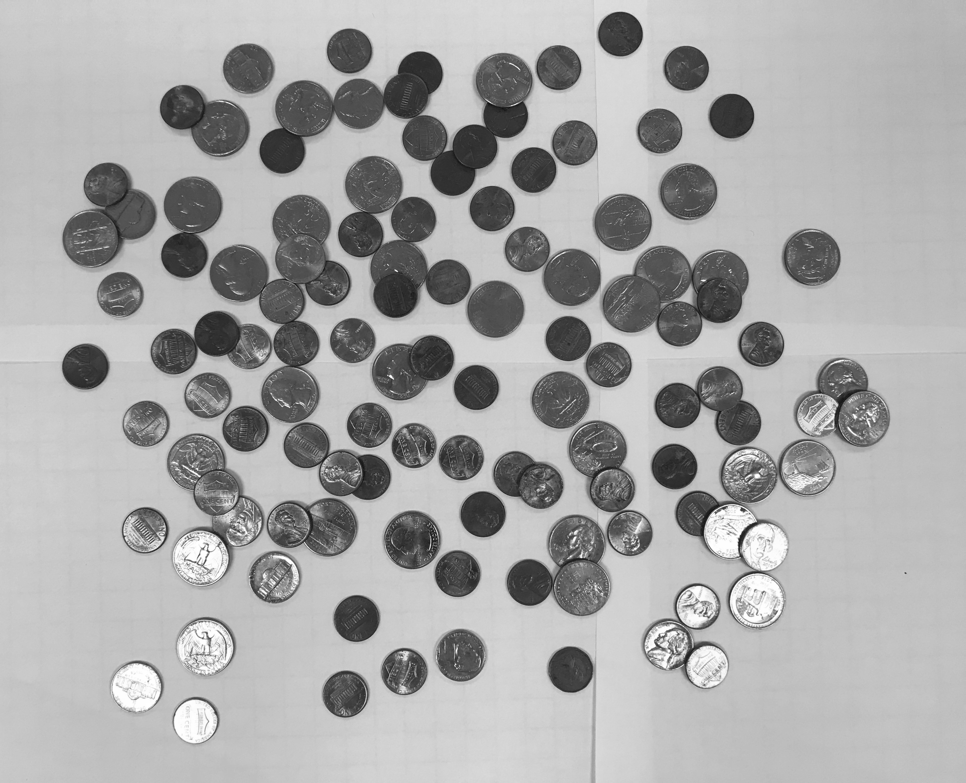

imagef.jpg:

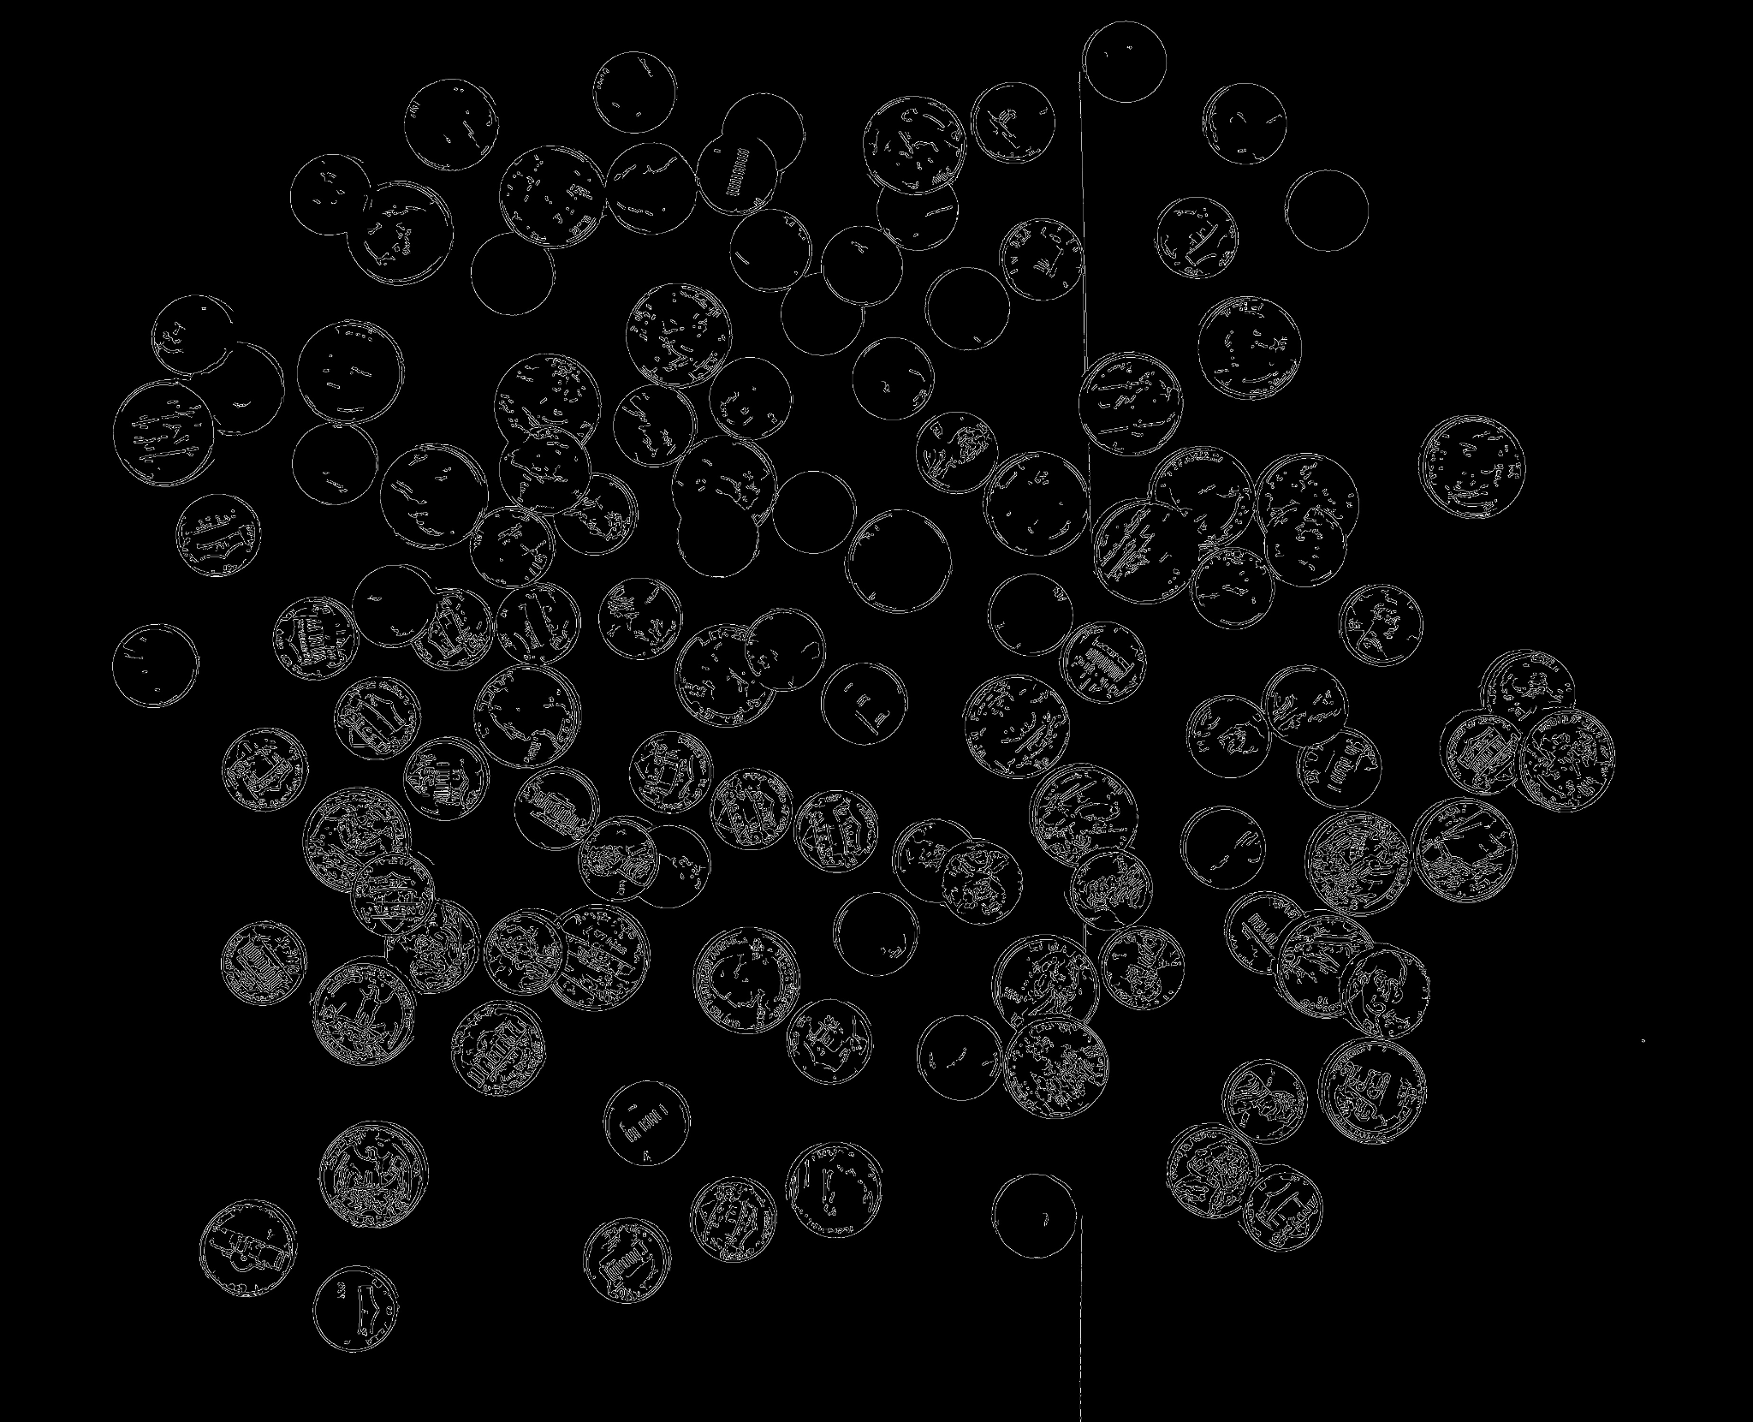

coins.jpg:

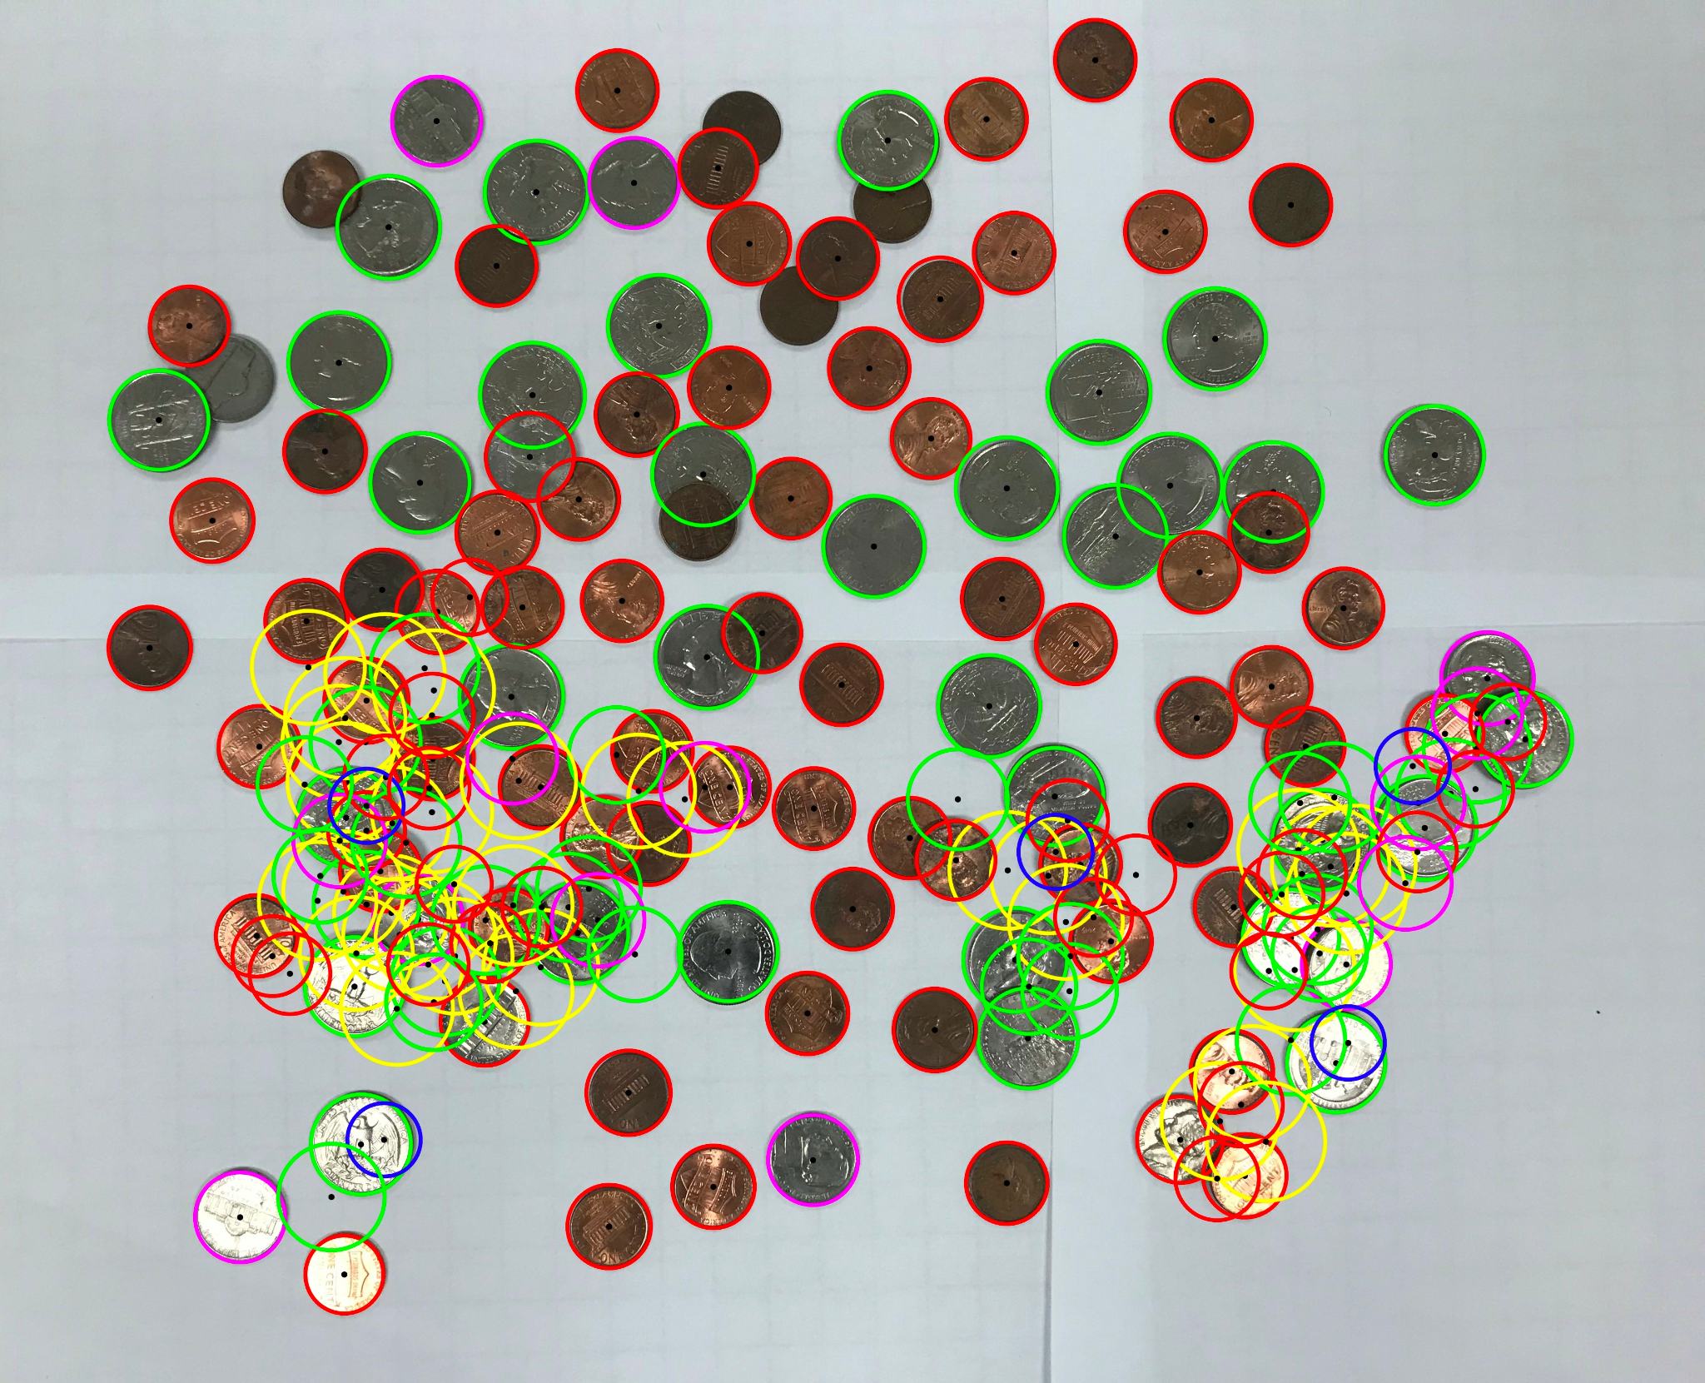

Content of results.txt:

5 dimes, 92 pennies, 14 nickels, 58 quarters, 33 silver dollars. Total sum: $33.12

1. For the hard image:

Command line including all parameter values used for this image:

./l071 -L 10 -H 100 -F coins3.jpg

Initial image:

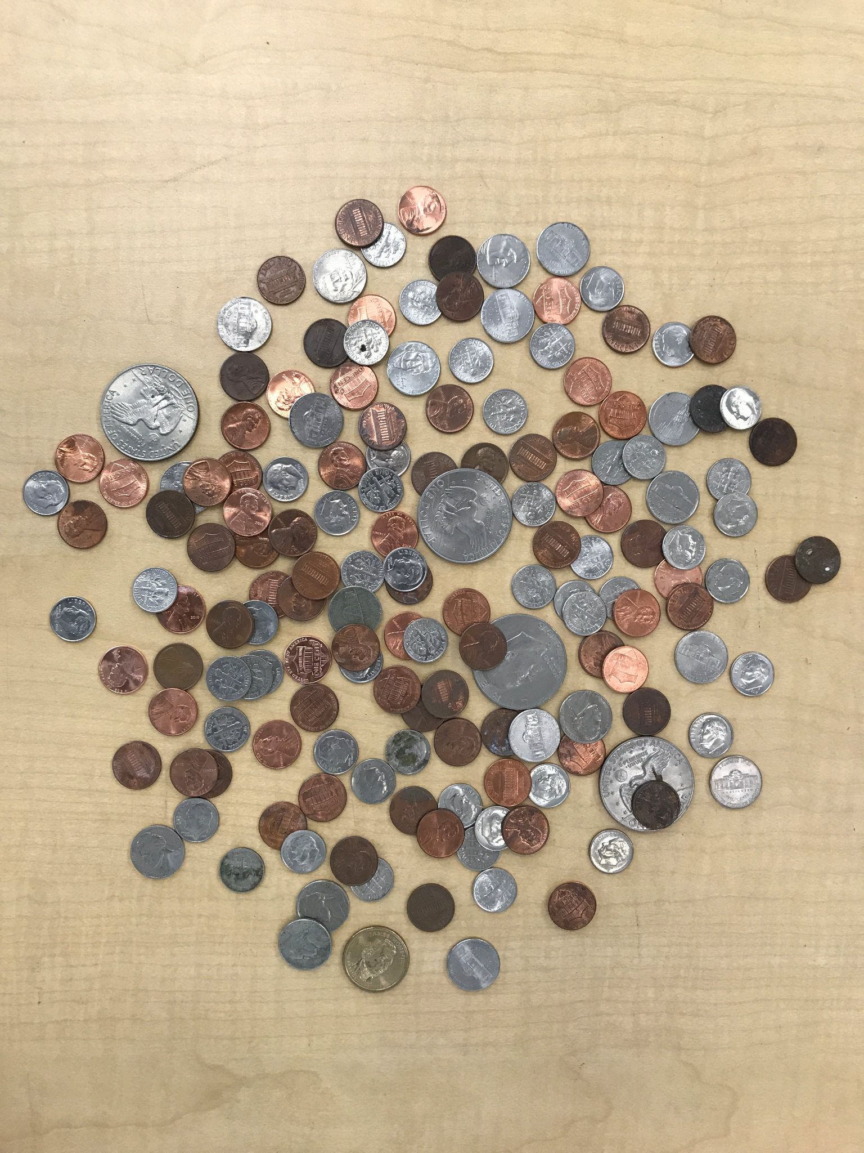

imageg.jpg:

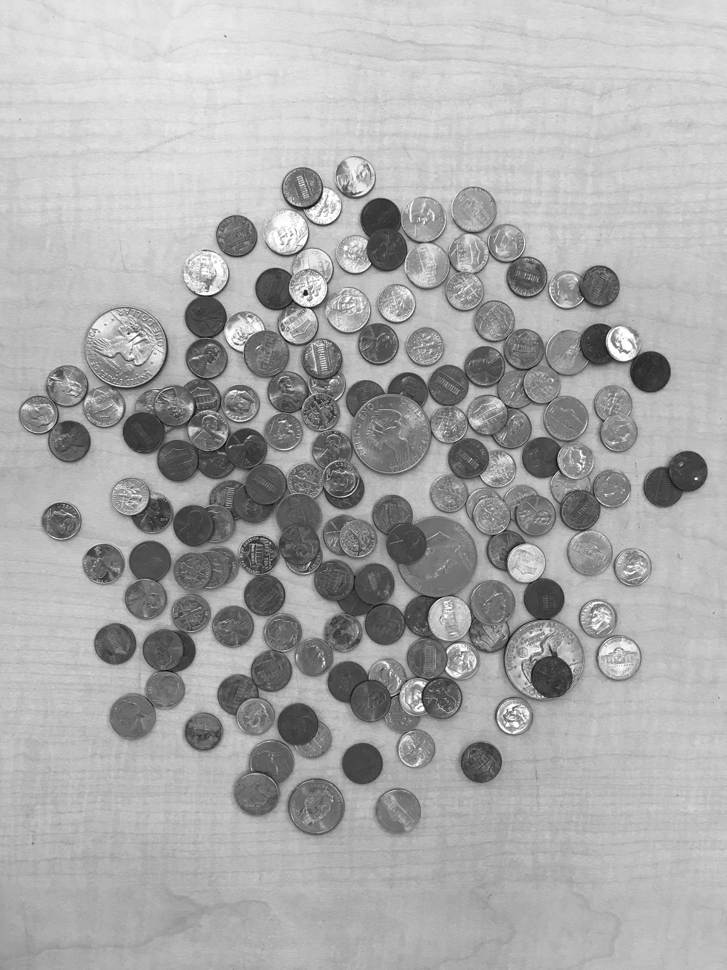

imagef.jpg:

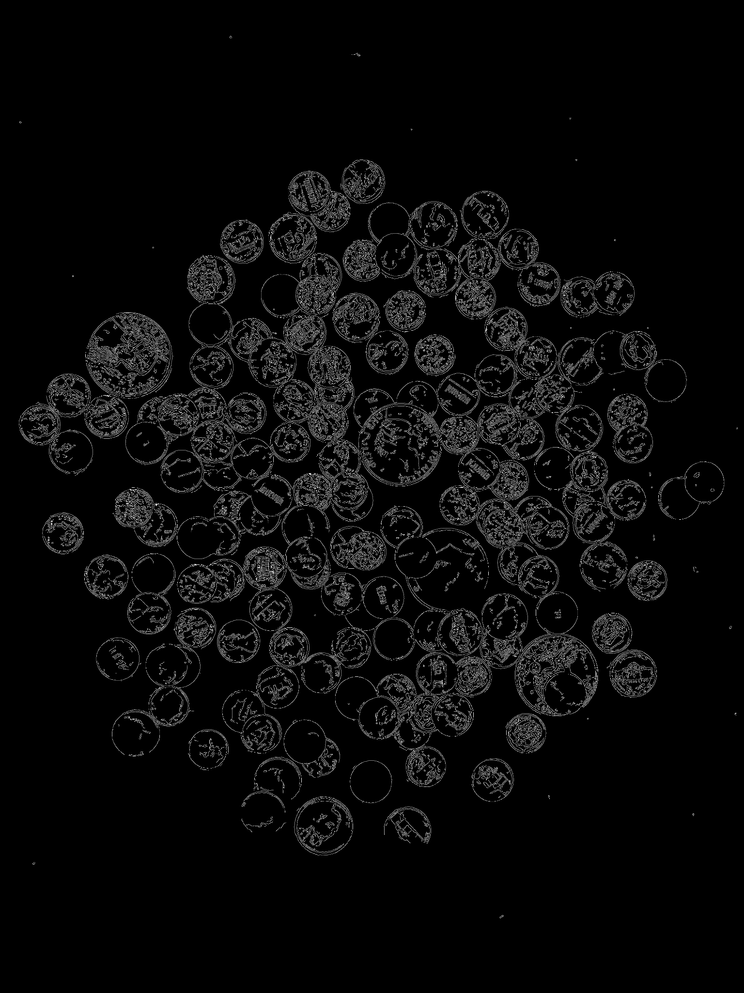

coins.jpg:

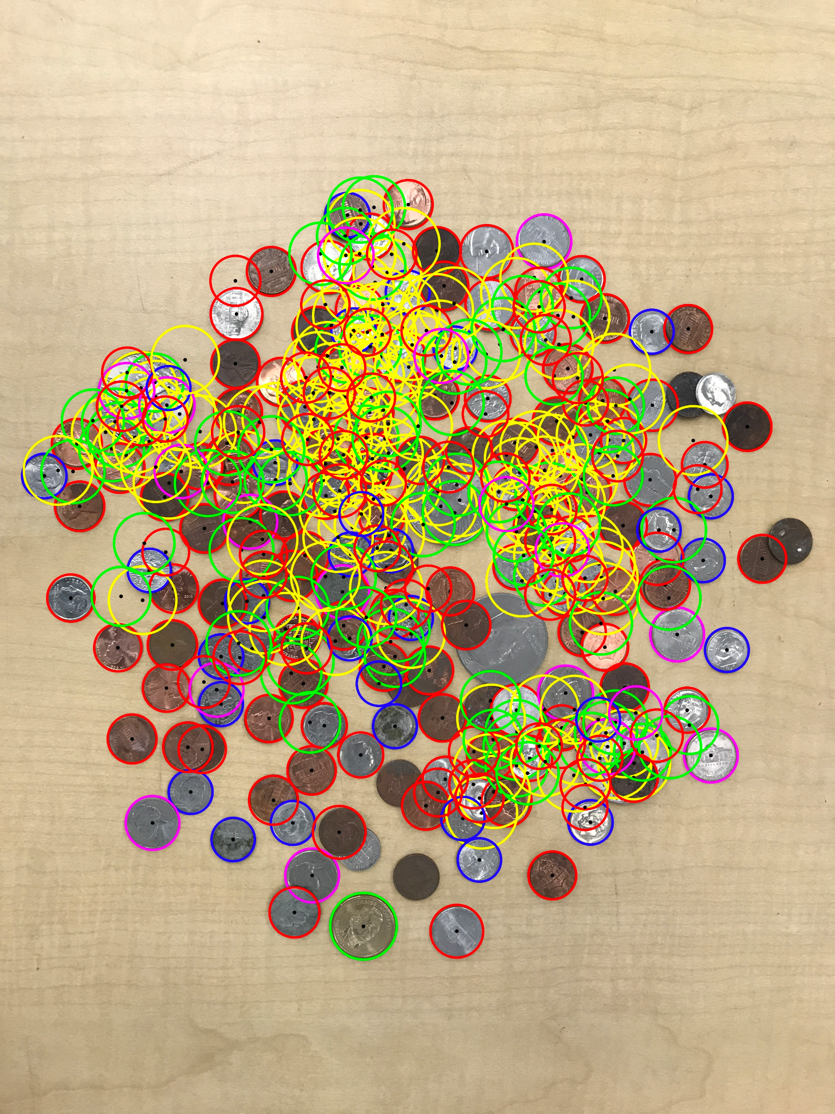

Content of results.txt:

30 dimes, 155 pennies, 18 nickels, 71 quarters, 131 silver dollars. Total sum: $88.7